**CENTRAL Zoo**

User Guide

|  |  |  |
| --- | --- | --- |
| **Supervisor.** | **Miss Muniba** | |
| **Batch.** | 2110F1 | |
| **Group.** | C | |
| **Serial No.** | **Enrollment Number** | **Student Name** |
| 1. | **1338868** | Tayyab Faisal |
| 2. | **1338683** | Shoaib |
| 3. | **1340163** | Haris |
| 4. | **1340159** | Shaffan |

**1.Home** (*the zoo.html*)

***Figure 1: Home page to Zoo***

“LET'S START A JOURNEY WITH US” ­­­­

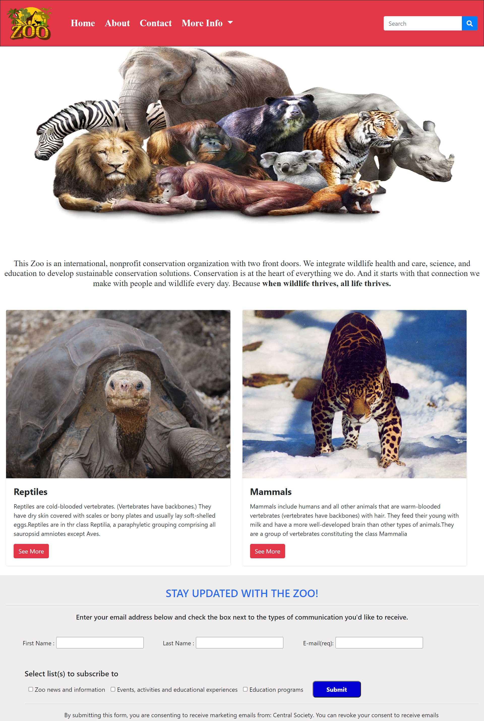

**2.Navbar (the zoo.html)**



***Figure 2: Navbar***

We have given four essentials. By clicking any of the essential’s and redirect to the linked page. (the zoo.html)

**3.About us (about.html)**

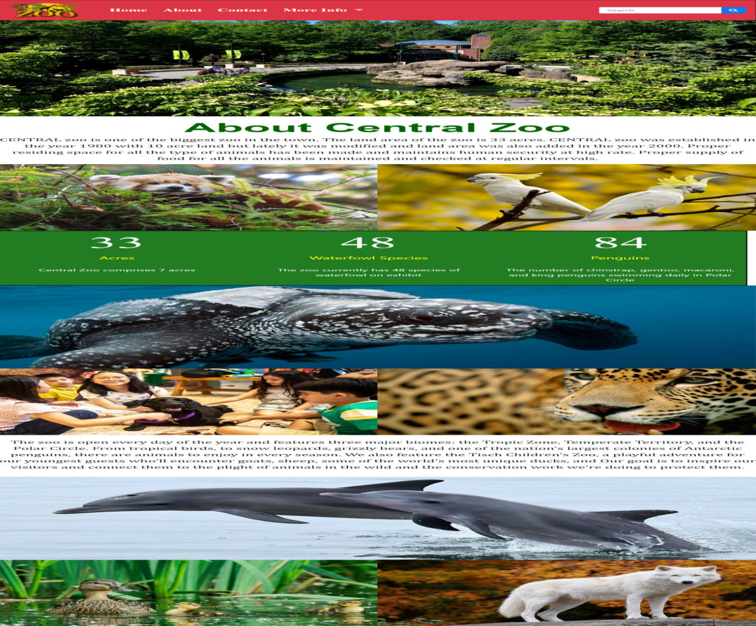

***Figure 3: About us***

* Central Zoo comprises 33 acres.
* The zoo currently has 48 species of waterfowl on exhibit
* 84 type of penguins.

**4.Reptiles (Reptiles.html)**

Some of the most Famous Reptiles are mentioned below:

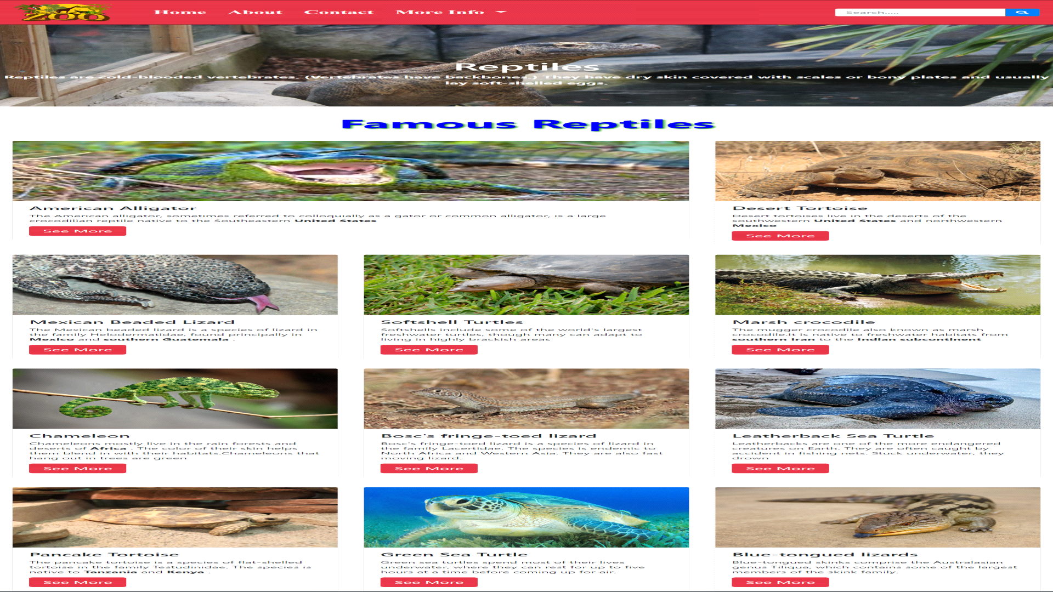

***Figure 4: Reptiles***

*We have mentioned our some famous reptiles & its characteristics. By Clicking on The See More button You can see the information of the required Reptiles*

***5.Mammals (index (1).html)***

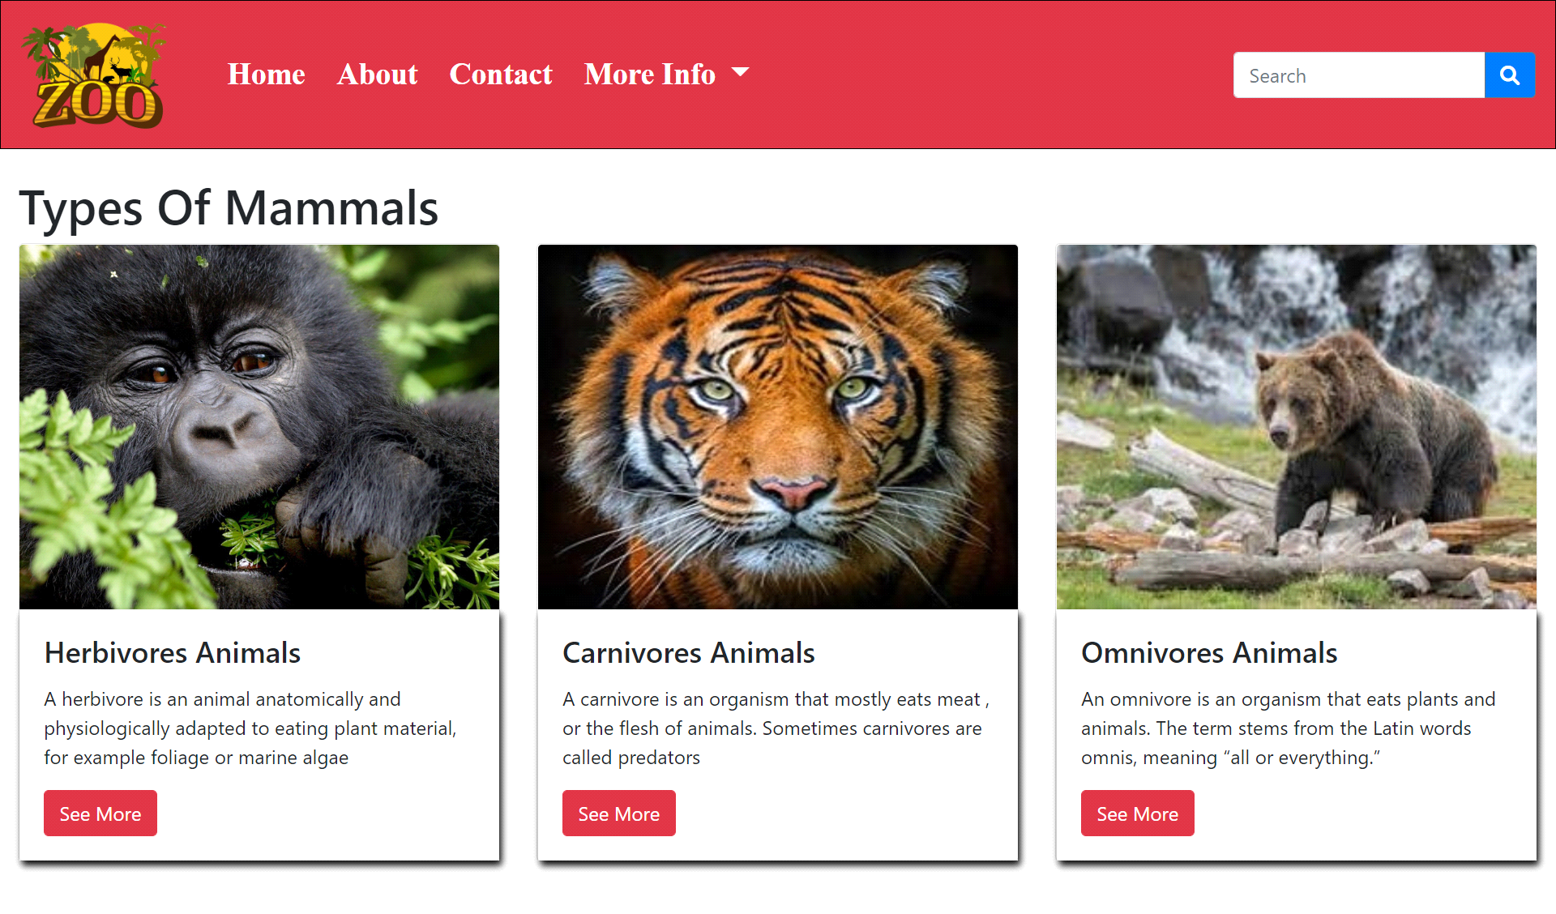

***Figure 5: Categories of mammals***

***Description:*** *Mammals are a group of vertebrates constituting the class Mammalia,.*

***“Category of mammals”***

*We have given three category of mammals.*

*And provide modal to highlight the name and characteristics so that people who are visiting our website can gain knowledge.*

* ***Carnivores***

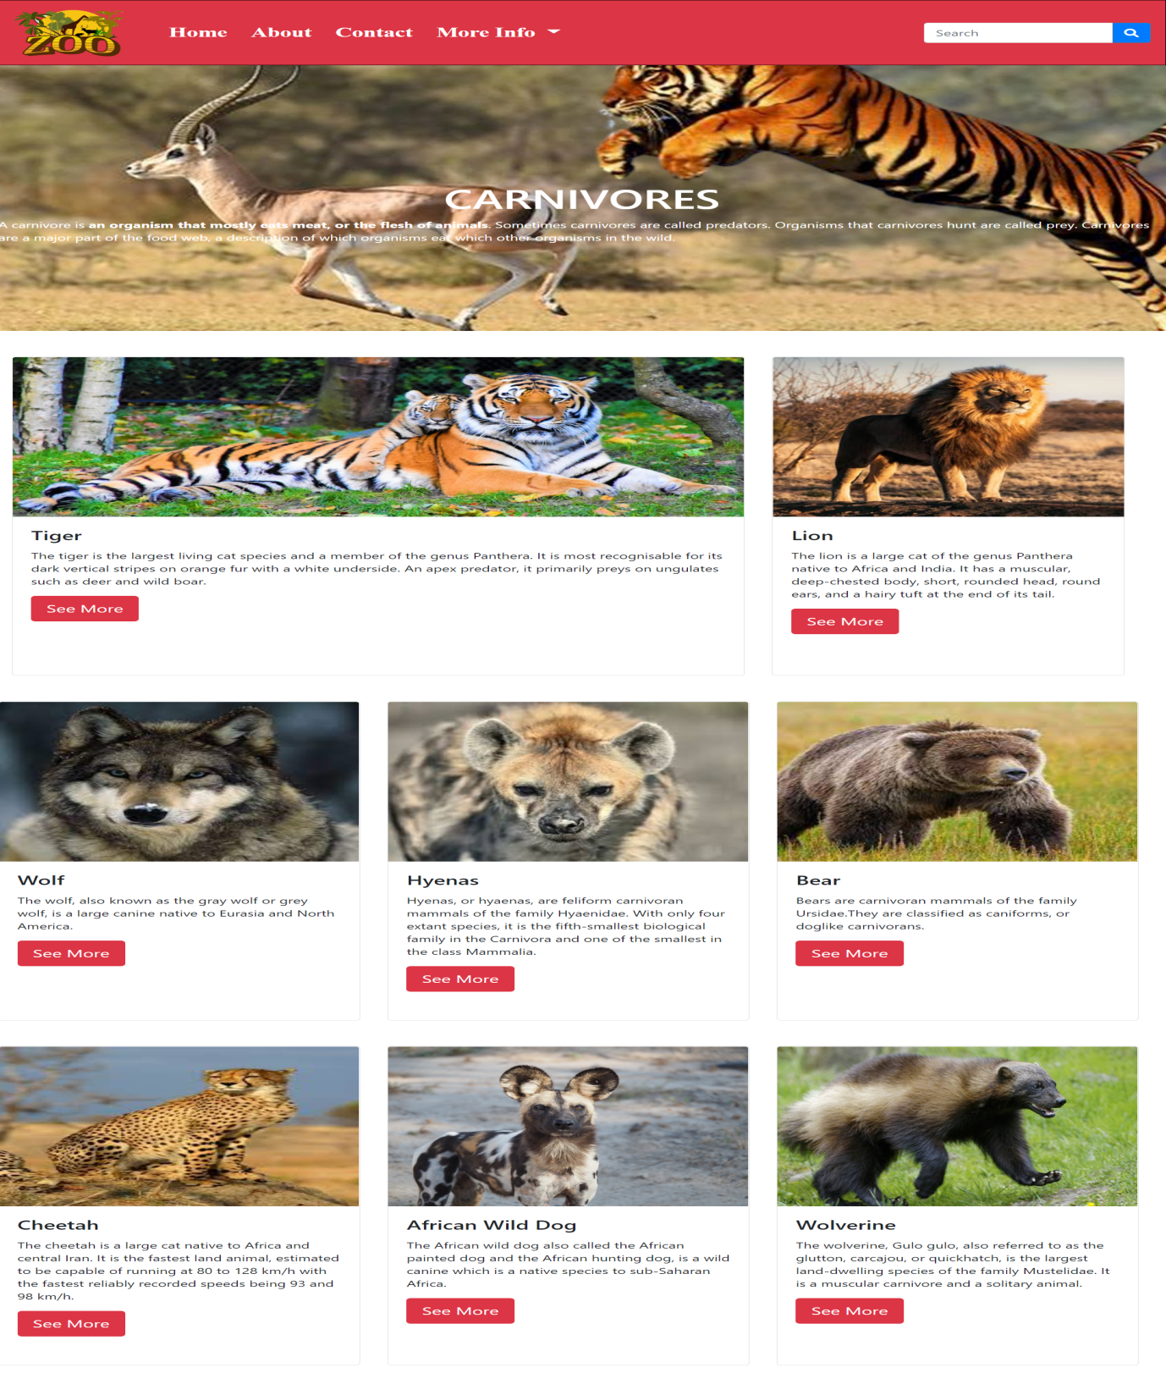

* ***Harbivores***

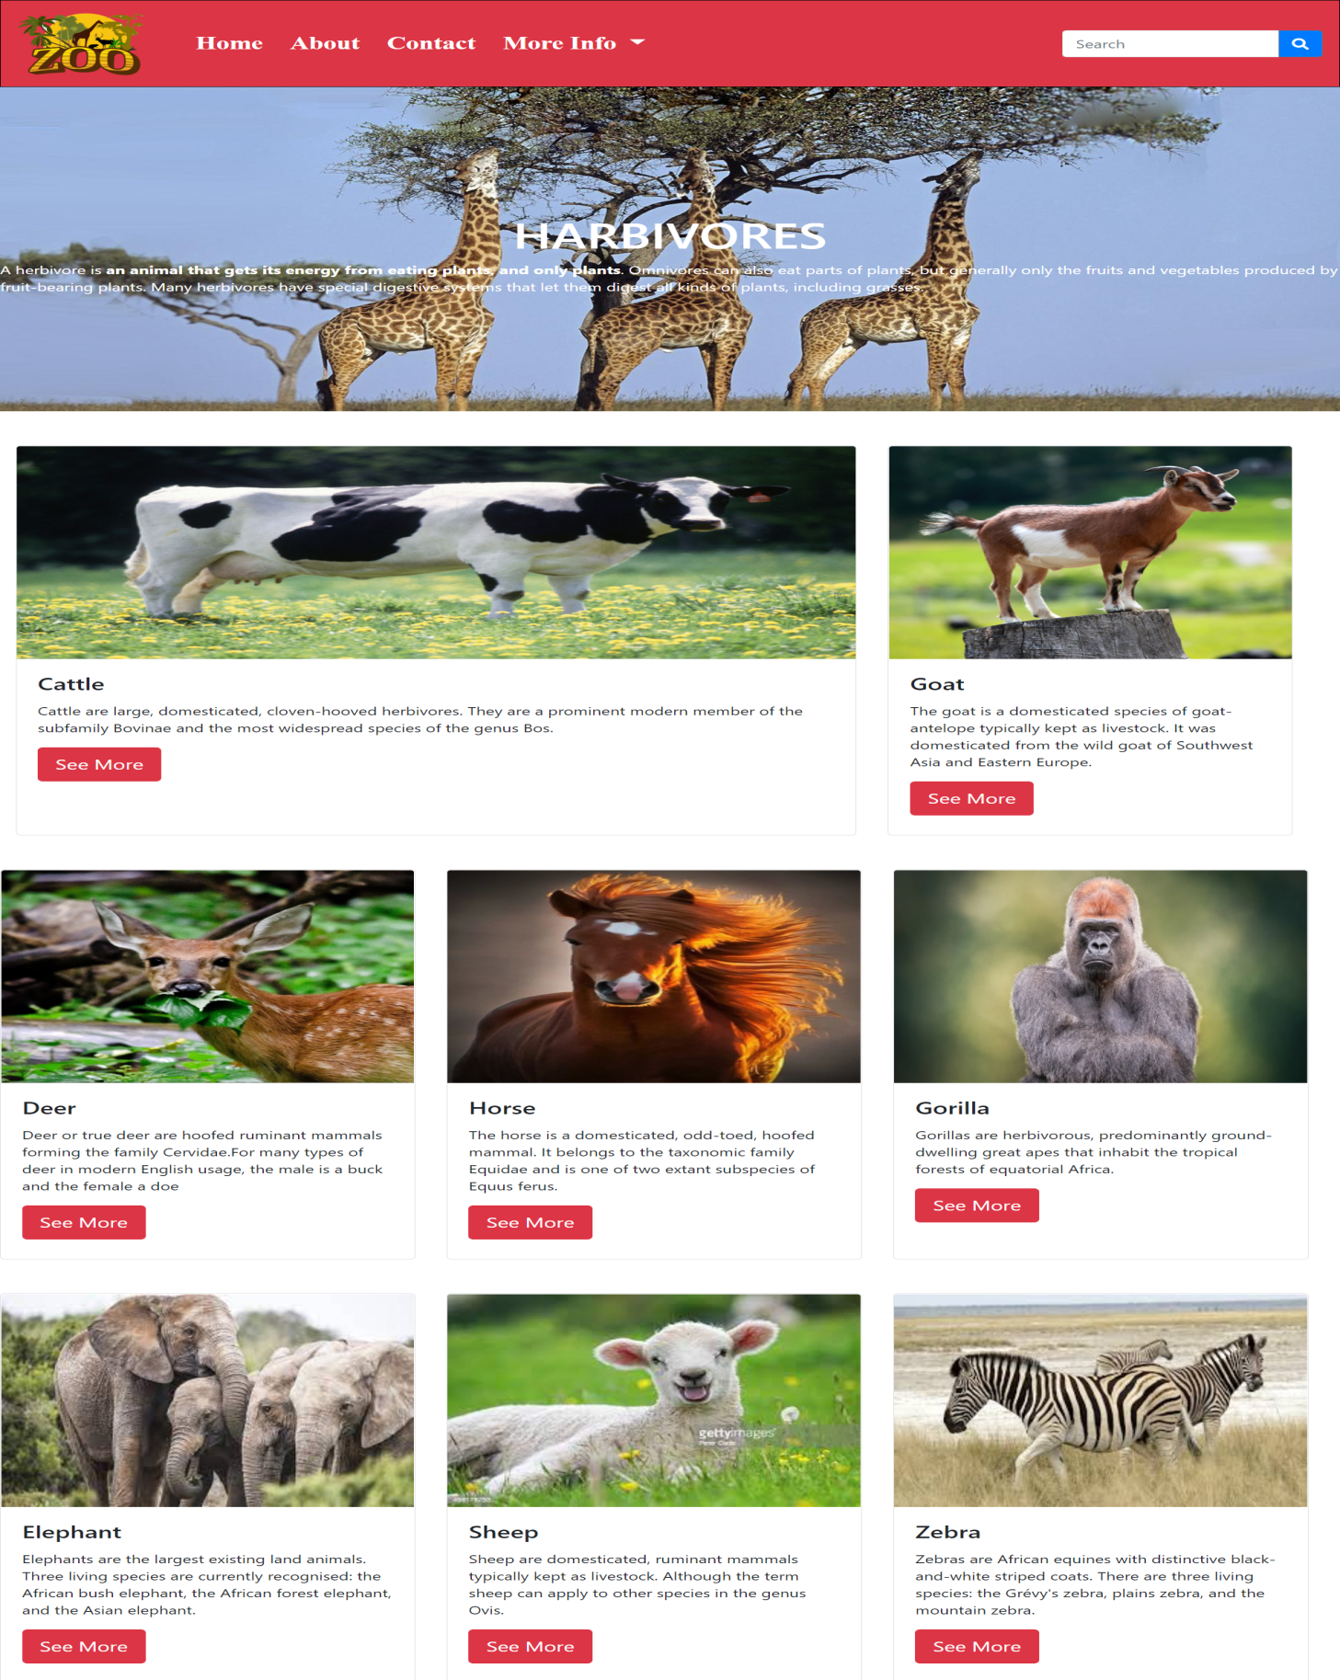

* ***Omnivores***

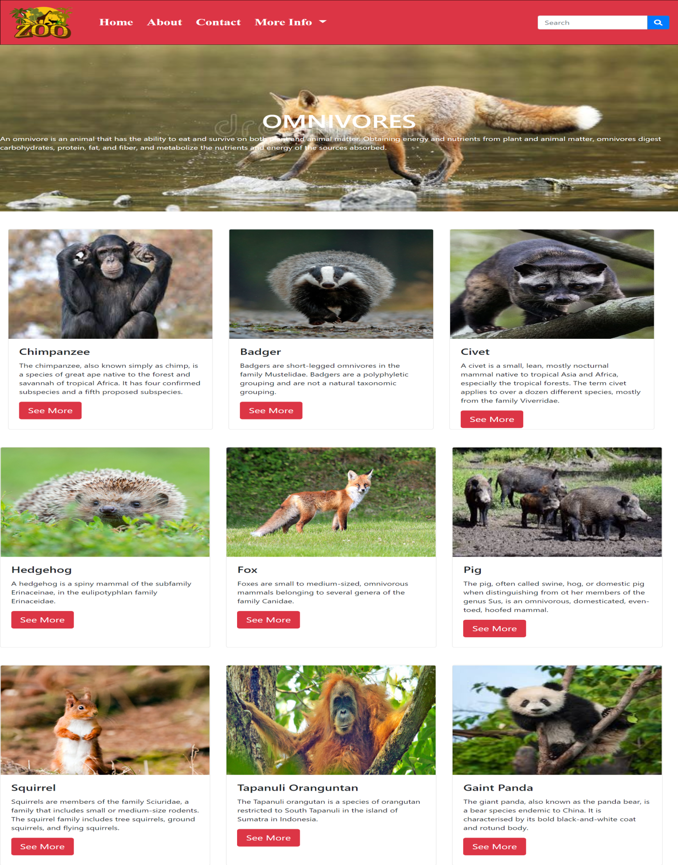

***6.Events (events.html):***

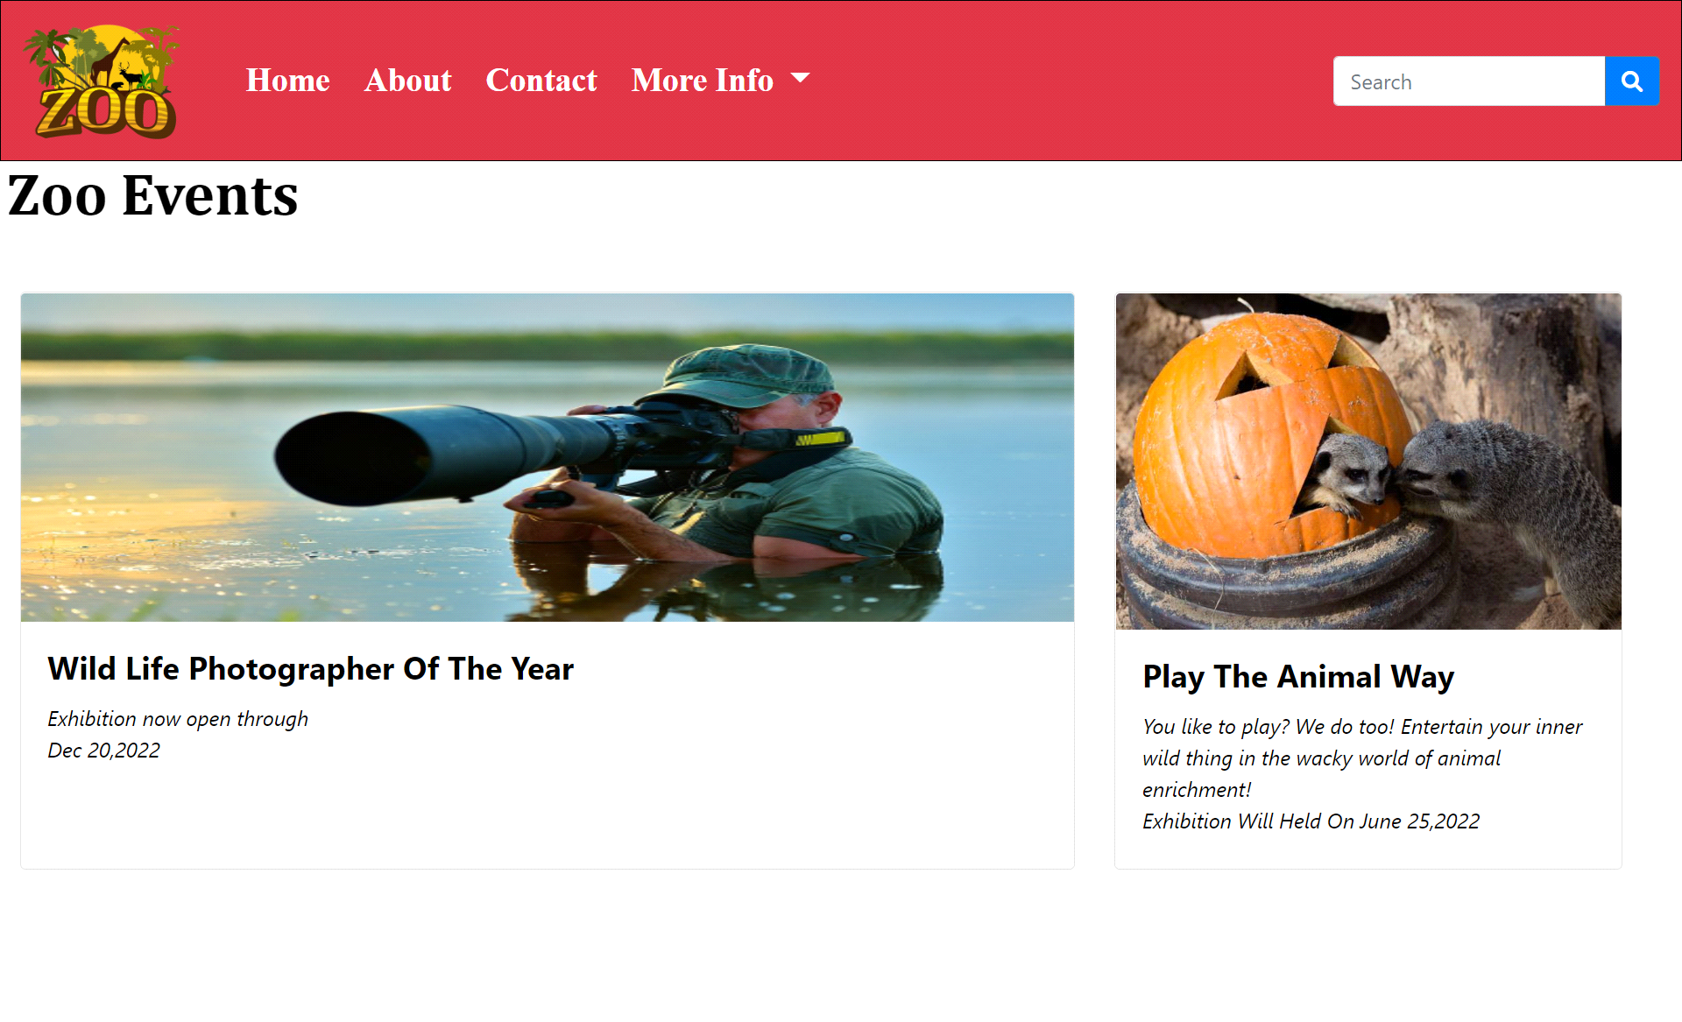

**Figure 6: Upcomming Events**

* Wildlife photographer of the year in Dec 20,2022
* Play the animal way in June 25,2022

***7.Ticket (ticket.html):***

The ticket Section is included in the website so that user can get and purchase the ticket by clicking on the Buy Now button. Prices are also mentioned for the children and adults etc.

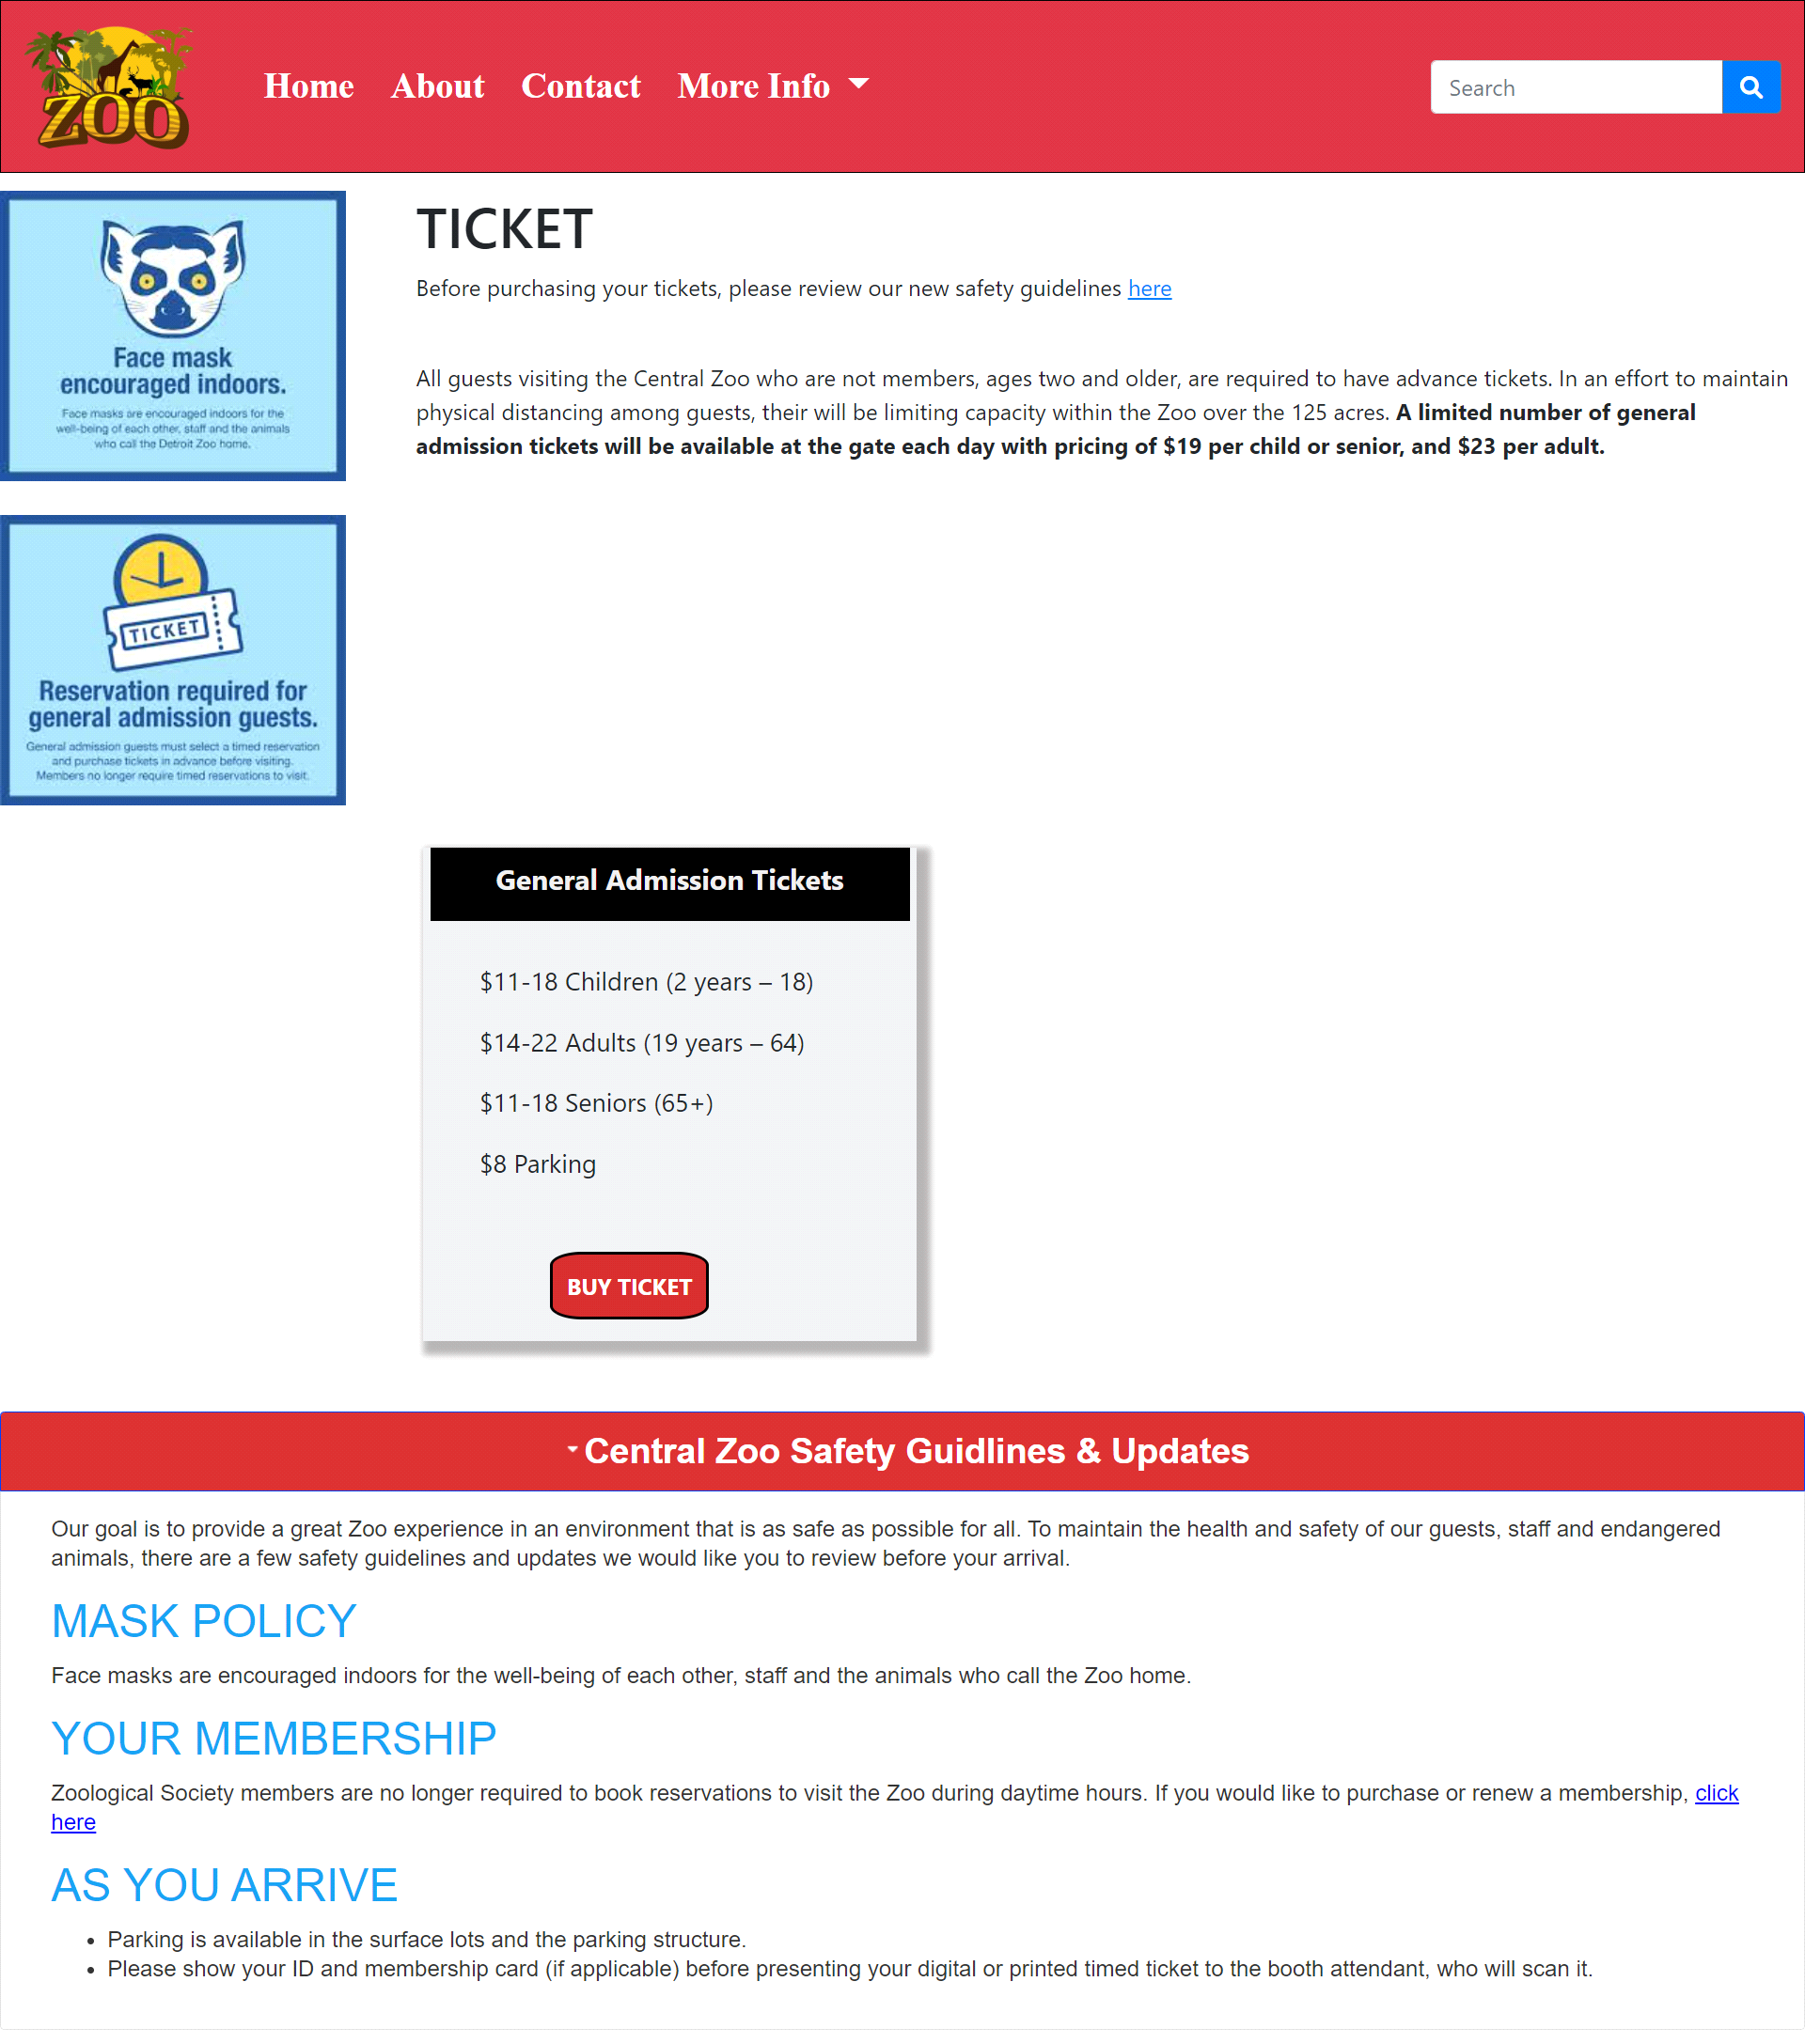

***Figure 7: Ticket***

* In our Ticket page we have given information about the ticket of the zoo and safety guidelines also.

***Booking Page:***

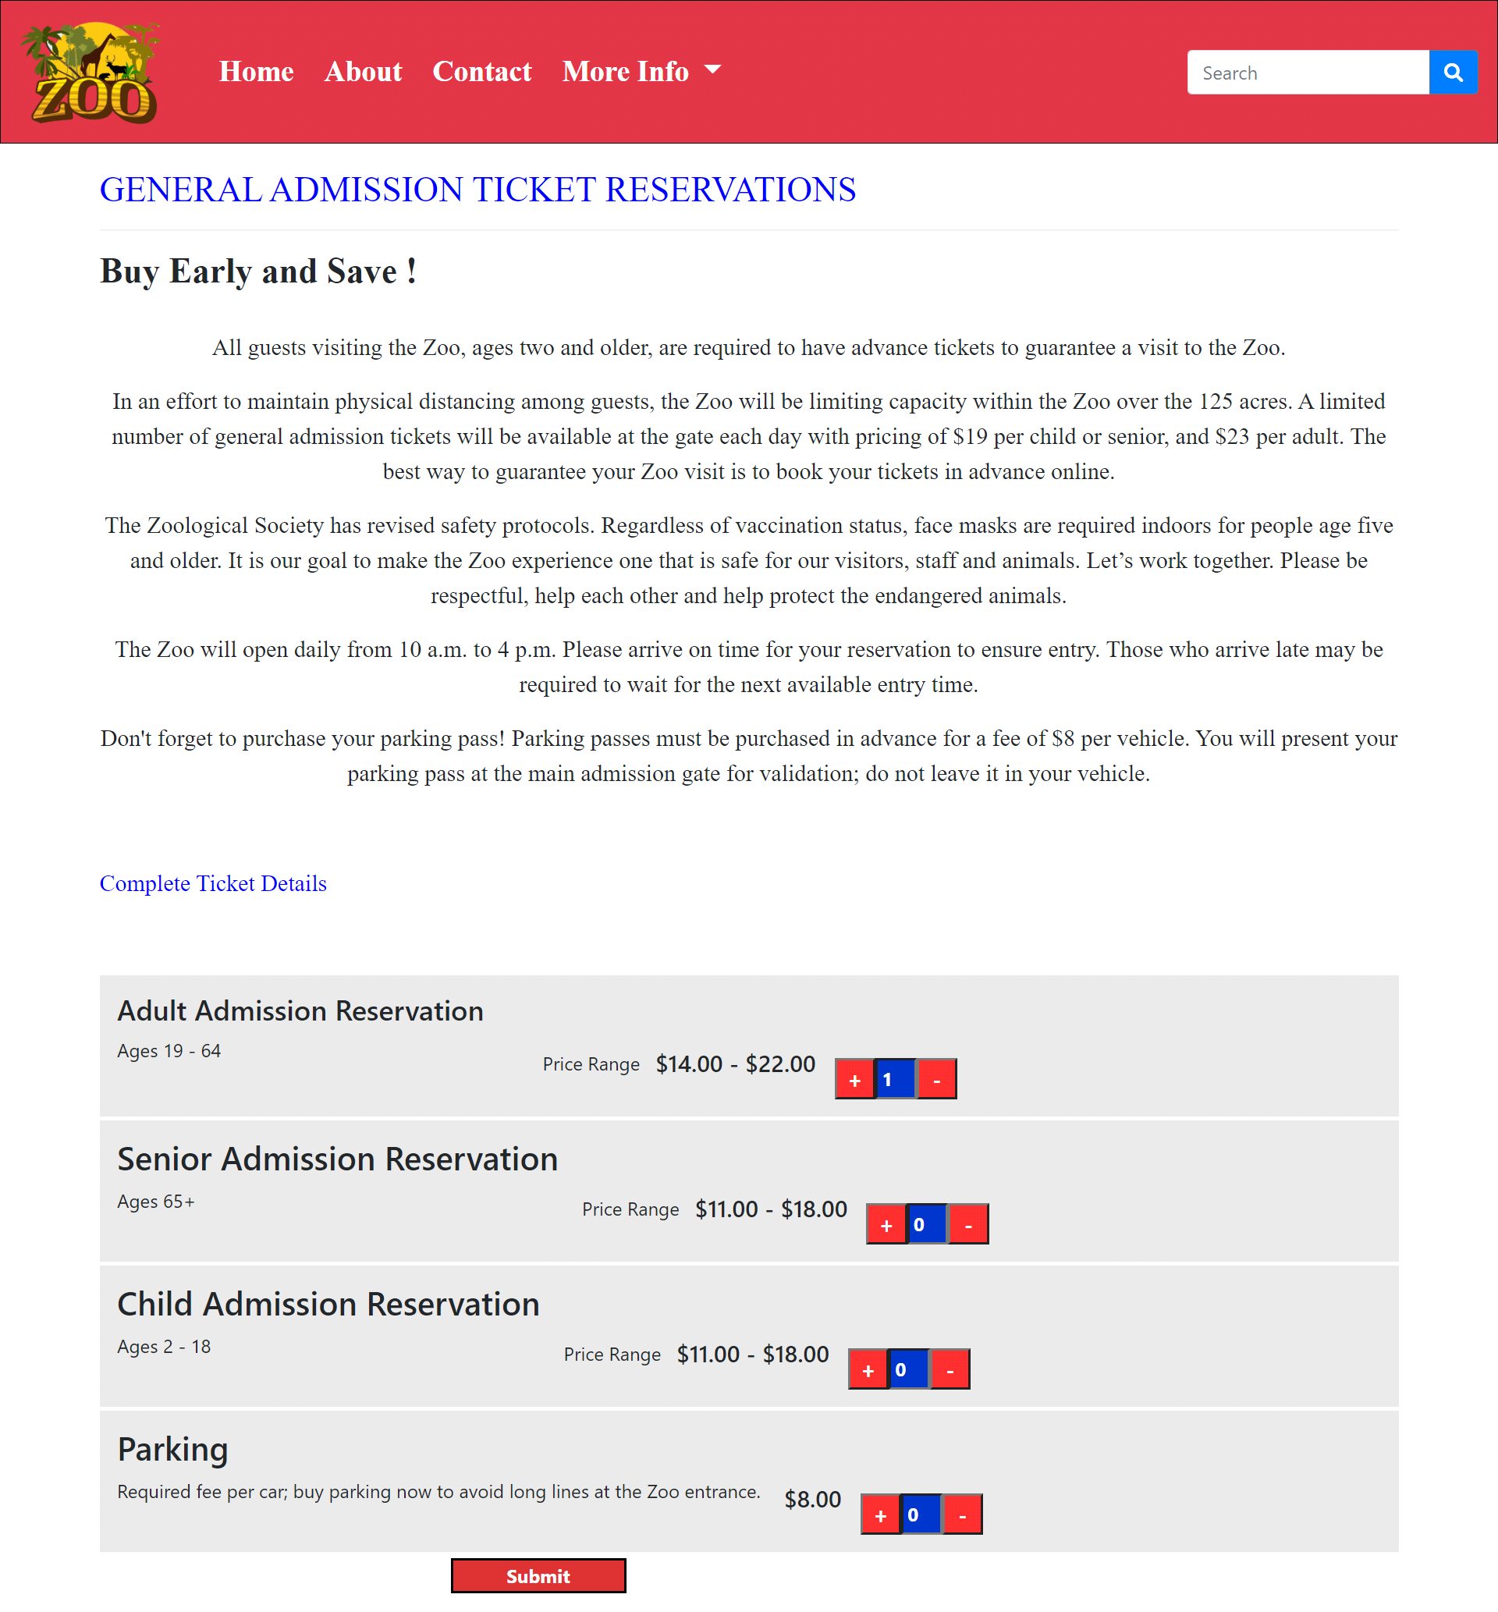

* In our Booking page we have given 3 category of ticket reservation and also avalible for vehicle parking.

8.***Questions About Zoo (ticket.html):***

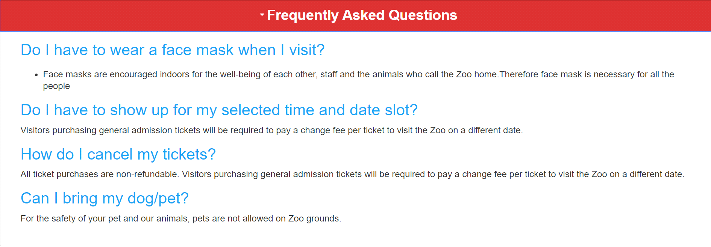

***Figure 8: Questions about Zoo***

Some of the most important questions of the zoo are mentioned. If any client has any query about our Zoo so they can have solutions over here.

***9.Membership (mambership.html):***

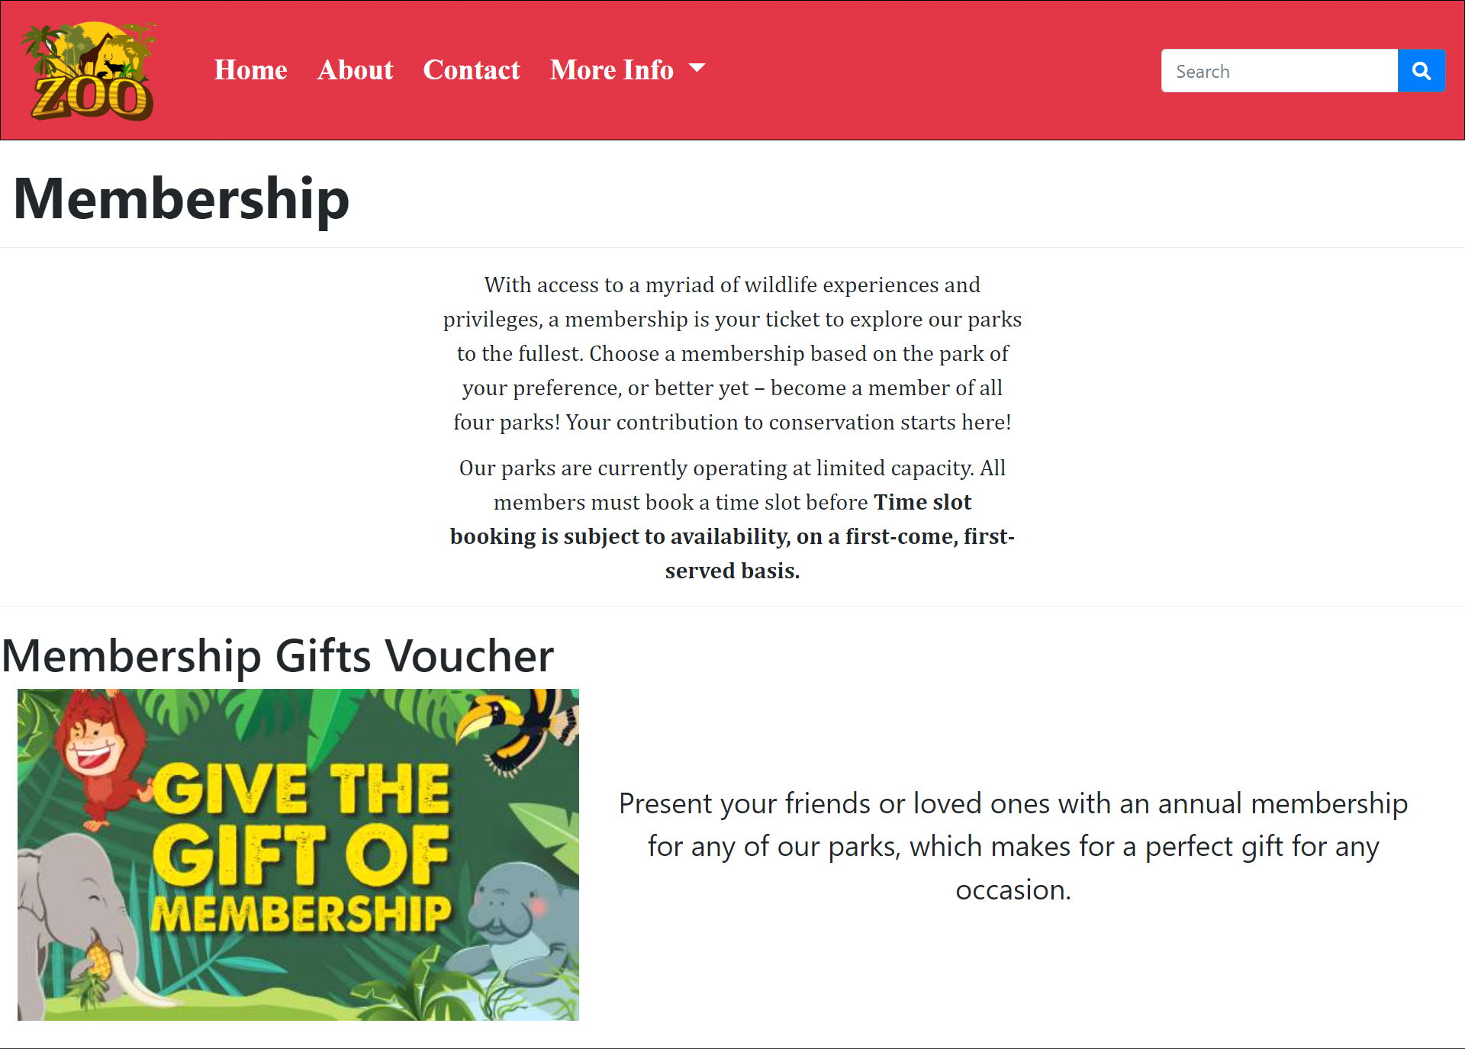

**10.Photo Policy *(photo policy.html):***

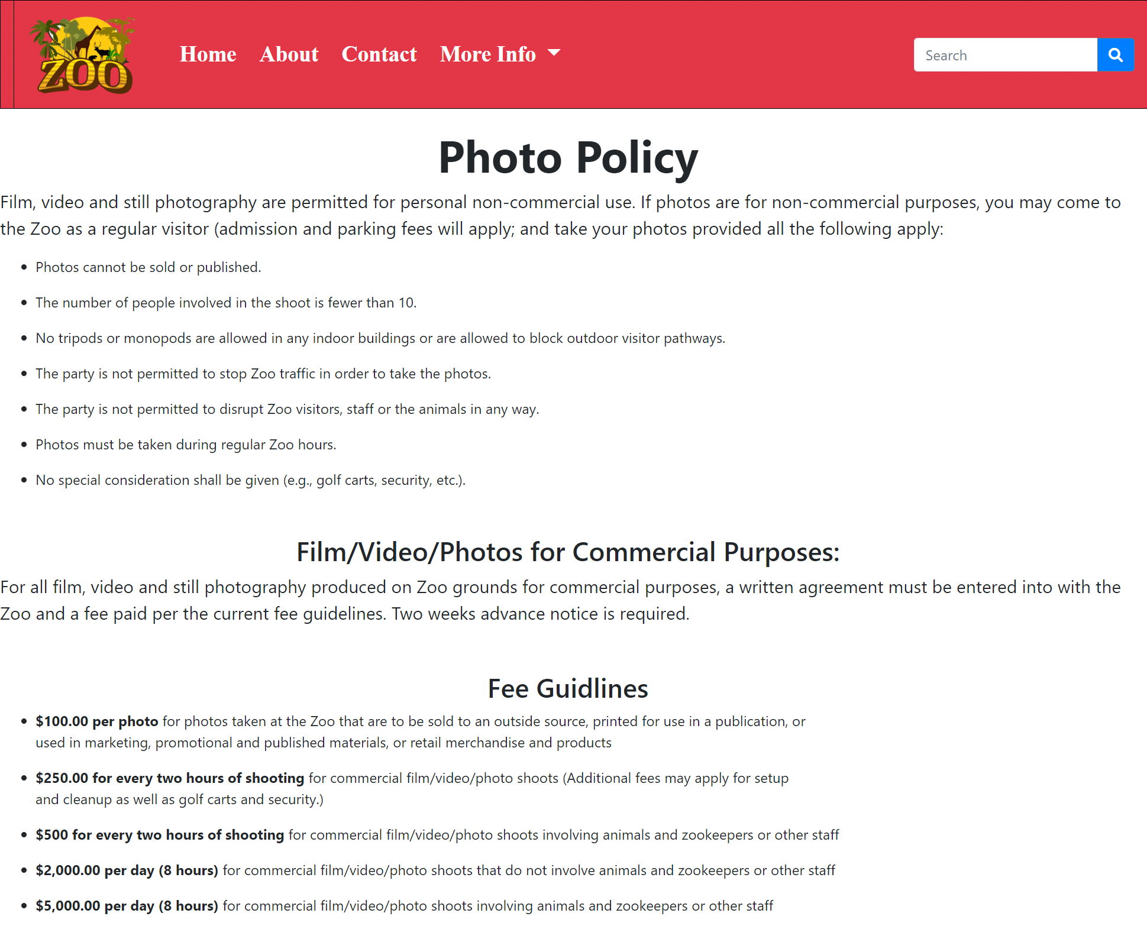

***Figure 10: Photo policy***

All information about photo shoot & video shoot and its policies

***11.Contact & Feedback (contact.html):***

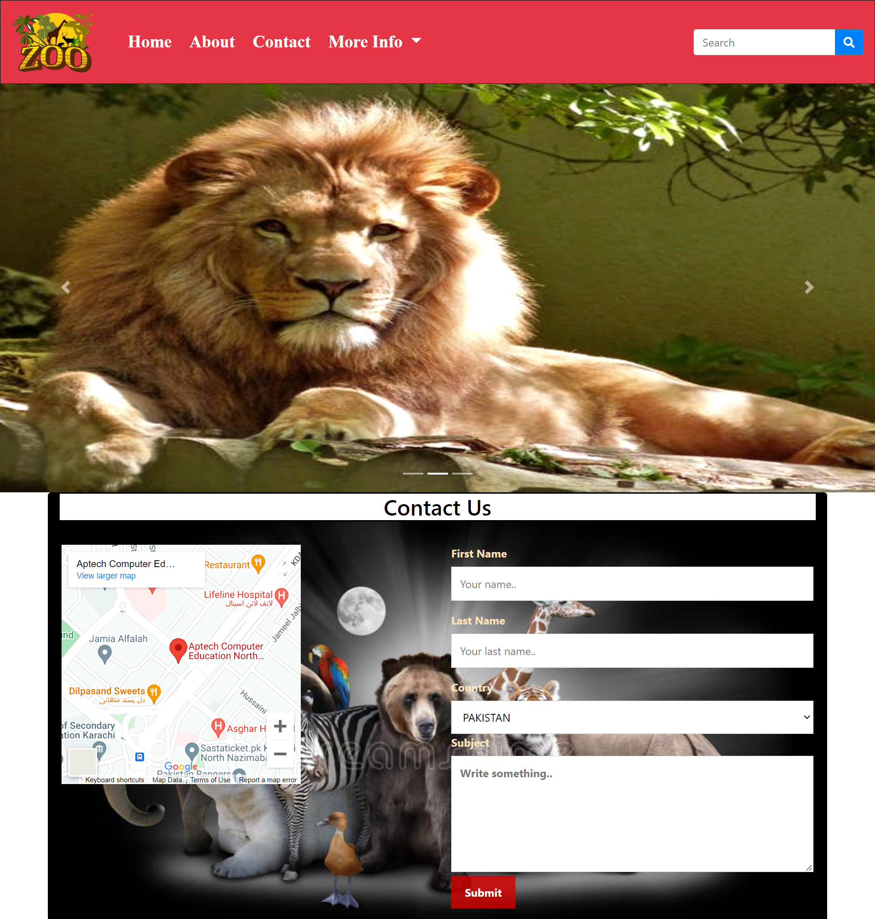

***Figure 11: Contact & Feedback***

*In our contact page we have given location map for the ease of the people*

*Email id and phone number for contacting in case of any problem and get positive feedback.*

*Update Form:*

*Ready To Updated From The Zoo.*

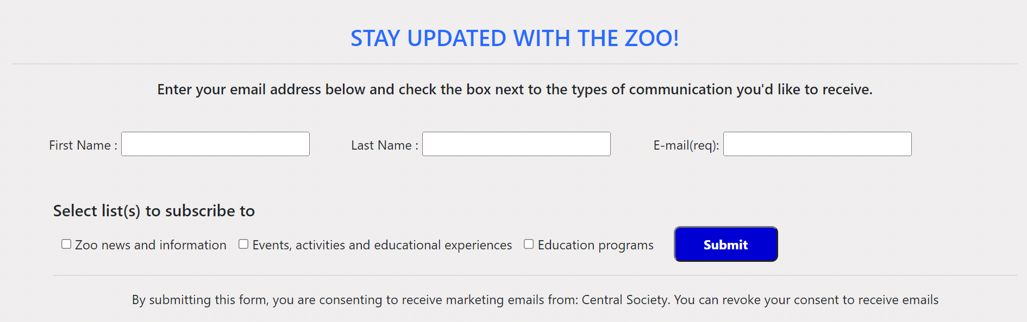

***12 Footer(the zoo.html):***

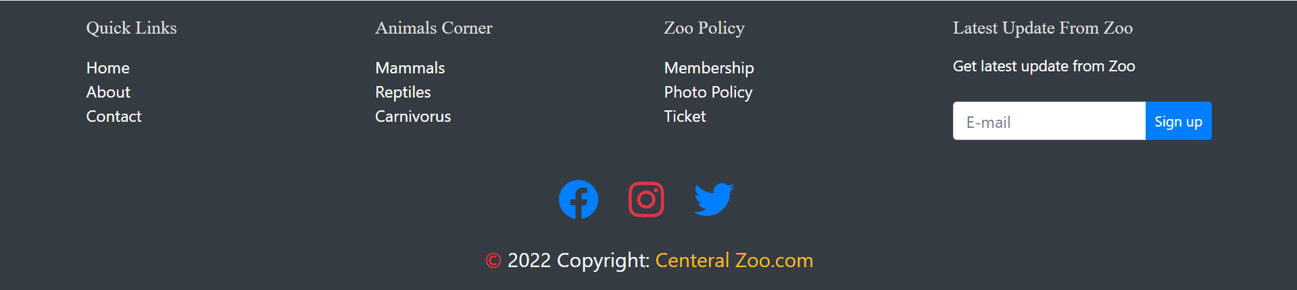

***Figure 12: Footer***

We have given all linked pages to access easily our website

Copyrights are given in the end of the website and effects of Facebook Instagram and twitter are also mentioned to contact and follow us.